**FI 393**

**Chapter 10—Net Present Value and Other Investment Criteria**

**Notes Outline**

1. **What is Capital Budgeting?**

Capital Budgeting is the process by which a firm determines _______________________

_______________________________________________________________________.

* + These projects can include:
    - Investing in R&D
    - Opening a new branch or location
    - Replacing or adding a machine to a production line
  + A project is *worth* pursuing if _________________________________________

_________________________________________________________________.

1. **We have several different capital budgeting criteria we can use to determine which project promise the best returns to the firm:**

* NPV (net present value)
* IRR (internal rate of return)
* PB (payback)
* DPB (discounted payback)
* MIRR (modified internal rate of return)
* PI (profitability index)

1. **Good Decision Criteria.** We need to ask ourselves the following questions when evaluating capital budgeting decision rules:
2. Does the decision rule _________________________________________________?
3. Does the decision rule _________________________________________________?
4. Does the decision rule _________________________________________________?
5. **Net Present Value.**

**Definition:** Net Present Value equals the difference between ______________________

_______________________________________________________________________

NPV answers: __________________________________________________________?

**Computation:**

1. Estimate the expected future cash flows.
2. Estimate the required return for projects of this risk level.
3. Find the present value of the cash flows and subtract the initial cost. That is:
$$NPV=PV of Cash Flows-PV of Cost$$

4. **NPV—Decision Rule.** State the decision rule:

A ______________ NPV means that the project is expected to add value to the firm and will therefore _______________________________________.

Because the goal of the financial manager is to increase __________________________, NPV is a direct measure of how well this project will meet this goal.

1. **Project Example Information.** You are reviewing a new project and have estimated the following cash flows:

* Year 0: CF = -165,000 (Initial Cost)
* Year 1: CF = 63,120
* Year 2: CF = 70,800
* Year 3: CF = 91,080
* Your required return for assets of this risk level is 12%.
* What is this project’s NPV?

1. **Computing NPV for this Project.** 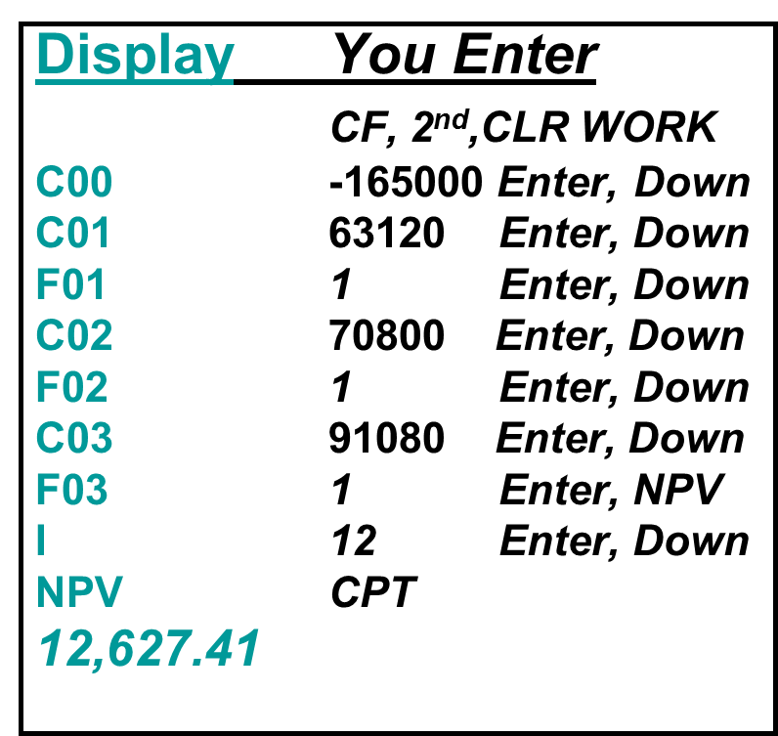Using the calculator:

Do we accept or reject the project?

1. **Rationale for NPV Method.**

* NPV = PV inflows – Cost
  + NPV=0 → Project’s inflows are “exactly sufficient to repay the invested capital and provide the required rate of return”
* NPV = net gain in shareholder wealth

**Rule:** Accept project if **__________________________________________________**.

1. **Decision Criteria Test—NPV.**

* Does the NPV rule account for the time value of money? If so, how?
* Does the NPV rule account for the risk of the cash flows? If so, how?
* Does the NPV rule provide an indication about the increase in value? If so, how?
* Should we consider the NPV rule for our primary decision rule?

1. **Advantages and Disadvantages of NPV.**

**Advantages**:

* Considers all of the __________ in the computation.
* Uses the ____________________________________________.
* Provides the answer in __________ terms, which is easy to understand.

**Disadvantages:**

* Requires the use of the ________________________________, thus a bit more difficult to compute.
* Projects that differ by orders of magnitude in ______________ are not obvious in the NPV figure.

1. **Payback Period.**

**Definition:** How _______ does it take to get the cost back in a __________ sense?

**Computation:**

1. Estimate the __________________________.
2. Subtract the future _____________________ from the _____________________ until the initial investment has been recovered.

**Decision Rule:** Accept the project if __________________________________________

**________________________________________________________________________**

1. **Project Example Information.** Going with the previous example:You are reviewing a new project and have estimated the following cash flows:

* Year 0: CF = -165,000 (Initial Cost)
* Year 1: CF = 63,120
* Year 2: CF = 70,800
* Year 3: CF = 91,080
* Your required return for assets of this risk level is 12%.
* What is this project’s payback period?

1. **Computing Payback for the Project.** Assume we will accept the project if it pays back within two years. The timeline of cash flows is below. Let’s compute payback:

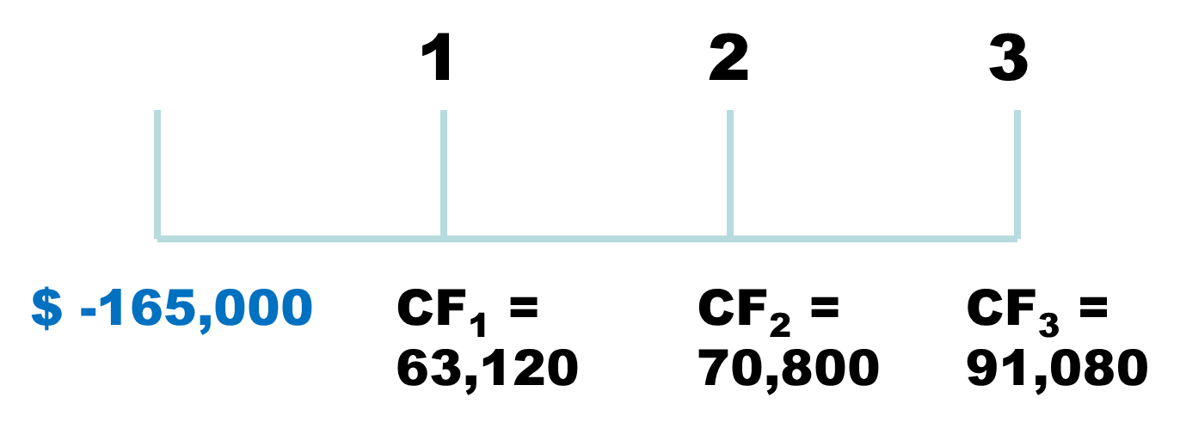

Year 1:

%

Year 2:

Year 3:

Do we accept or reject the project?

1. **Decision Criteria Test—Payback.**

* Does the payback rule account for the time value of money? If so, how?
* Does the payback rule account for the risk of the cash flows? If so, how?
* Does the payback rule provide an indication about the increase in value? If so, how?
* Should we consider the payback rule for our primary decision rule?

1. **Advantages and Disadvantages of Payback:**

**Advantages:**

* Easy to understand.
* Adjusts for __**UNCERTAINTY**___ of later cash flows.
* Biased toward _**Liquidity**___.

**Disadvantages:**

* Ignores the _**Time Value of Money**___.
* Requires an arbitrary cut off point.
* Ignores cash flows __**Beyond the Cutoff Pt**____.
* Biased against __**Long-Term**___ projects, such as new research and development and new projects.

1. **Internal Rate of Return.**
   * This is the most important alternative to _**NPV**_(Golden Standard)__.
   * It is often used in practice and intuitively appealing.
   * It is based entirely on the _____________________________ and is independent

of ______________________________ found elsewhere.

1. **IRR—Definition and Decision Rule.**

**Definition:** IRR is the _**Return**________ that _**makes the NPV=0**__.

**Decision Rule:** Accept the project if __**the IRR is greater than the required return**___.

* Said another way: If the IRR of a project is _**greater**_ than the firm’s

__**Firms Cost of Capital**___, then we would _**Accept**___ the project.

1. **Computational Comparison of NPV to IRR.**

NPV: Enter __**r**____, solve for __**NPV**______.

$$\sum_{t=0}^{n}{\frac{{CF}_{t}}{{(1+R)}^{t}}=NPV}$$

IRR: Enter NPV = _**0**___, solve for __**IRR**____.

$$\sum_{t=0}^{n}{\frac{{CF}_{t}}{{(1+IRR)}^{t}}=0}$$

1. **Computing IRR for the Project.** If you do not have a financial calculator, then this computation becomes a trial and error process.

* Calculator:
  + Enter the CFs as you did with NPV.
  + Press IRR and then CPT.
  + IRR = __**16.3%**__, which is **_>**_ required return of _**12%**_.
* Do we accept or reject the project?

**Accept**

1. **NPV Profile for the Project.**

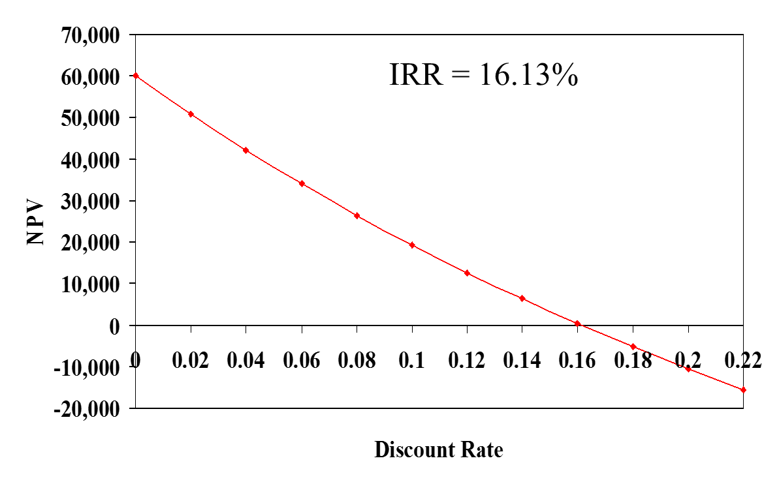

1. **Decision Criteria Test—IRR.**

* Does the IRR rule account for the time value of money? If so, how?

**Yes**

* Does the IRR rule account for the risk of the cash flows? If so, how?

**Yes**

* Does the IRR rule provide an indication about the increase in value? If so, how?

**Yes**

* Should we consider the IRR rule for our primary decision rule?

**Yes, Except if it agrees w/ NPV**

1. **Advantages of IRR.**

* Knowing a __***Return***___ is intuitively appealing.
* It is a simple way to communicate the value of a project to someone who doesn’t know all of the estimation details.
* If the IRR is high enough, you may not need to estimate a __***Required Return***__, which if often a difficult task.

1. **Summary of Decisions for the Example Project.**

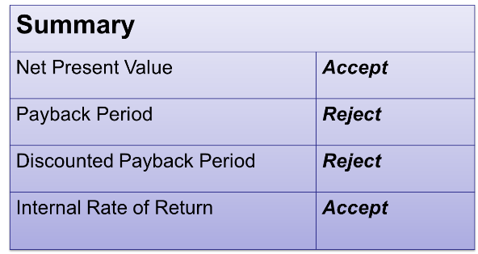

* So, what should we do? We have two rules that indicate to accept the project and one that indicates to reject.

***NPV and IRR generally give u the same decision.***

1. **NPV vs. IRR.** NPV and IRR **generally** give us the same decision.

* Exceptions:
  + Nonconventional cash flows—cash flow signs change more than one time.
  + Mutually exclusive projects.
    - __***Intial Investments***__ are substantially different (issue of scale).
    - _***Timing***_ of cash flows is substantially different.

1. **IRR and Nonconventional Cash Flows.**
   * When the cash flows change sign more than once, there is more than one IRR.
   * When you solve for IRR, you are solving for the root of an equation, and when you cross the x-axis more than once, there will be more than one return that solves the equation.
   * If you have more than one IRR, which one do you use to make your decision?
2. **Another Example: Nonconventional Cash Flows.**
   * Suppose an investment will cost $90,000 initially and will generate the following cash flows:
   * Year 1: $132,000
   * Year 2: $100,000
   * Year 3: -$150,000
   * The required return is 15%.
   * Should we accept or reject the project?
     + First compute the NPV: _***1769.54***_.
     + Next compute the IRR: _***10.11***_.
3. **NPV Profile.**

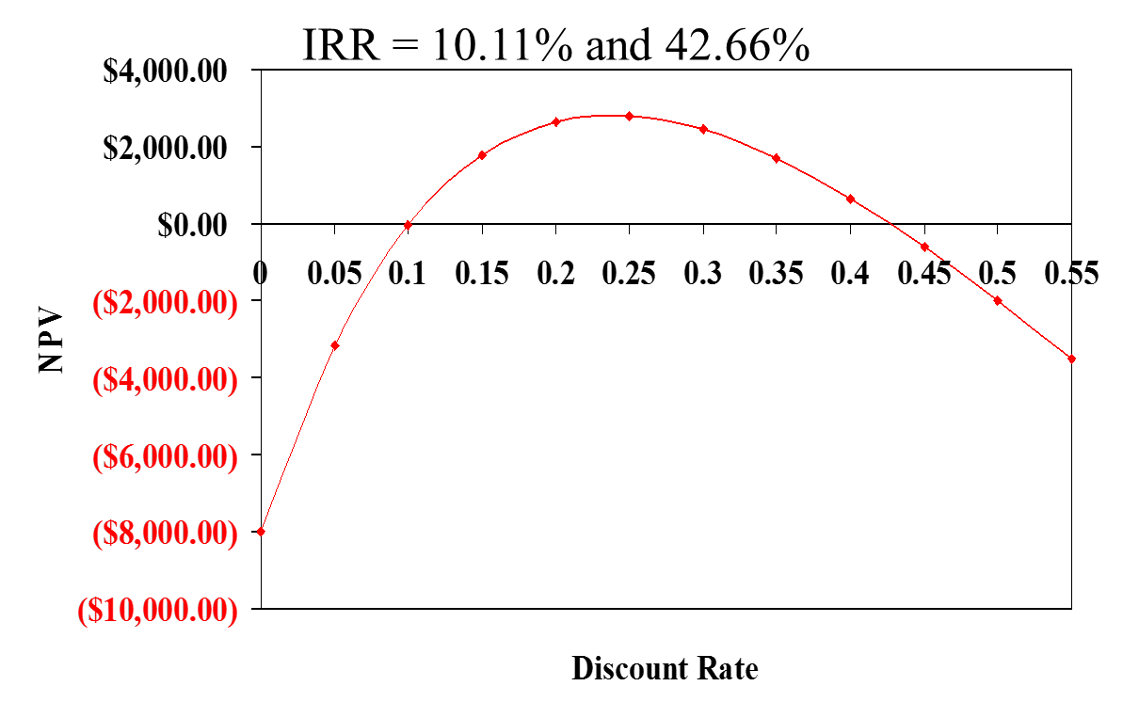

* You should accept the project if the required return is between __***10.11%***___ and _***42.66%***____.

1. **Summary of Decision Rules.**

* The NPV is __***1769.54***_ at a required return of 15%, so you should _***Accept***_.
* If you use the financial calculator, you would get an IRR of __***10.11%***_, which would tell you to _***Reject***__.
* You need to recognize that there are non-conventional cash flows and look at the NPV profile.

1. **IRR and Mutually Exclusive Projects.**
   * Mutually Exclusive Projects:
     + If you choose one, you can’t choose the other.
     + Example: You can choose to build an Italian restaurant or a motorcycle shop on the same property, but not both.

Intuitively, you would use the following decision rules:

* NPV—choose the project with the ______________ NPV.
* IRR—choose the project with the _______________ IRR.

1. **Example with Mutually Exclusive Projects.** The required return for both of the following projects is 10%.

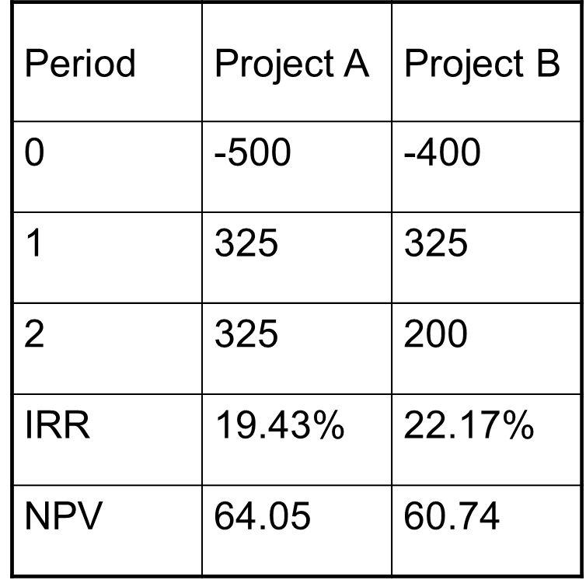

Which project should you accept and why?

1. **NPV Profiles.**

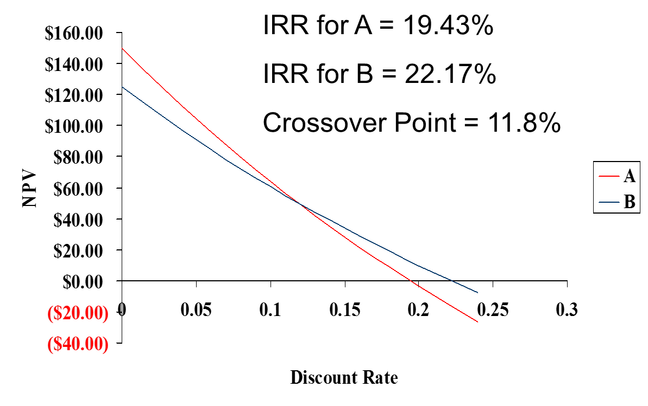

* If the required return is less than the crossover rate of 11.8%, then you should choose _____.
* If the required return is greater than the crossover rate of 11.8%, then you should choose _____.

1. **Conflicts between NPV and IRR.**

* NPV directly measures the ____***Increase in Value***___ to the firm.
* When there is a conflict between NPV and another decision rule, _***Always Use NPV***_.
* IRR is unreliable in the following situations:
  + Nonconventional cash flows.
  + Mutually exclusive projects.

1. **Profitability Index.**

* Measures the benefit per unit cost, based on the __________________________.
* A profitability index of 1.1 implies that for every $1 of investment, we create an additional _________ in value.
* This measure can be very useful in situations in which we have limited capital.

1. **Profitability Index.**

For conventional CF projects:

$$PI=\frac{\sum_{t=1}^{n}{\frac{{CF}_{t}}{{(1+r)}^{t}}}}{|{CF}_{0}|}$$

1. **Advantages and Disadvantages of Profitability Index:**

**Advantages:**

* Closely related to _***NPV***______, generally leading to identical decisions.
* Easy to understand and communicate.
* Maye be useful when available investment funds are limited.

**Disadvantages:**

* May lead to incorrect decisions in comparisons of mutually exclusive investments.

1. **Capital Budgeting in Practice.**

* We should consider several investment criteria when making decisions.
* *_****NPV****_ and _* ***IRR****_____ are the most commonly used primary investment criteria.*
* __ ***PAYBACK***__ is a commonly used secondary investment criteria.
* All provide valuable information.

***[REJECT IF PI < 1]***